
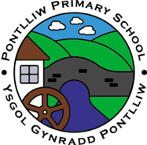
Pontlliw Primary School
Ysgol Gynradd Pontlliw
Planting the seeds for a lifetime of growth – Plannu hadau dyfi am oes

Curriculum for Wales Summary
Crynodeb cwricwlwm I gymru

Respect – Parch Care – Gofal Community - Gymuned
Our Vision  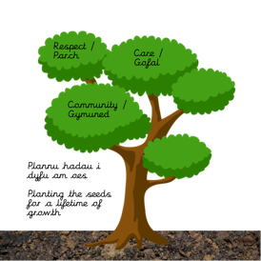  Our curriculum is based on our school motto, ethos and values. It is broad, balanced, inclusive and relevant to our pupil’s needs. It introduces pupils to real life contexts and experiences making cross-curricular links. Pupil led learning ensures that there is an enjoyment of learning which stimulates the mind of every child, irrespective of culture, identification and needs, in order that every child can reach their full potential. It is our aim that, as our pupils leave us, they do so equipped with the enthusiasm and skills needed to enter the next phase of their education and the challenges beyond that with a love of learning. | The four purposes  At Pontlliw Primary, we support all learners in their journey to achieving the four purposes. The four purposes are at the heart of our curriculum and the school’s teaching and learning. They are what we hope our learners will become at the end of their educational journey:  - ambitious, capable learners ready to learn throughout their lives  - enterprising, creative contributors, ready to play a full part in life and work.  - ethical, informed citizens of Wales and the world  - healthy, confident individuals, ready to lead fulfilling lives as valued members of society.
Our Values  Respect – Parch Care – Gofal Community - Gymuned  Our School develops these values with all stakeholders to reflect what is important to our school community. Our school needs to be a place where everyone and everything is respected, everyone feels they belong, and everyone feels cared for. The pupils have developed simple rules for all stakeholders to adhere to and have a collective responsibility to ensure that our school is a place where everyone feels happy, safe and secure and is invested in their community. | Statements of what matters  Our curriculum will provide opportunities and experiences to develop the key concepts, knowledge and skills described in the statements of what matters and in line with the What Matters Code.
Our inclusive curriculum  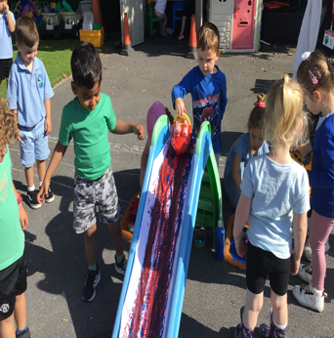  Our curriculum will raise the achievements and attainments of all learners. As a school we have considered how all learners will be supported to realise the four purposes and to progress. We have considered our ALN provision and how we will meet the needs of different groups of learners. | Areas of learning and experiences  The curriculum is now structured into 6 Areas of learning and experience (AoLEs):  - Languages, Literacy and Communication (English, Welsh and a modern foreign language - French).  - Expressive Arts (Art, dance, drama, film, digital media and music).  - Science and Technology (Science, design, craft and technology and information communication technology)  - Humanities (History, Geography and Religion, Values and Ethics)  - Maths and Numeracy  - Health and Well-being (personal and social education, physical education and relationships and sexuality education)

Learning Progression and Assessment  Our curriculum supports learning through designing learning opportunities that draw upon the pedagogical principles, which will enable all learners to make meaningful progress over time. Leaners will improve and develop their skills and knowledge. Our curriculum focuses on understanding what it means to make progress in a given area or discipline, and how learners should broaden and deepen their knowledge and show their understanding through the application of their knowledge in a variety of contexts. It is informed by our progression document which, in turn, supports our approach to assessment, the purpose of which is to inform planning for the next step of learning. All learners will be assessed on entry to the school. | RSE  Our curriculum embraces the guidance in the RSE code. Our RSE provision will have a positive and empowering role in our learner’s education and will play a vital role in supporting them to realise the four purposes as part of a whole-school approach. Helping learners to form and maintain a range of relationships, all based on mutual trust and respect, is the foundation of RSE. These relationships are critical to the development of emotional well-being, resilience and empathy.
Welsh and English  As an English medium school, learning will take place in Welsh and English from Nursery through to Year 6. | RVE  Religion, Values and Ethics (RVE) is a statutory requirement of the curriculum for Wales and is mandatory for all learners from ages 3 to 16. There is no parental right to request that a child is withdrawn from RVE in the curriculum for Wales. As RVE is a locally determined subject, the agreed syllabus specifies what should be taught in RVE within the City and County of Swansea.
Cross-curricular skills  Our curriculum will develop the mandatory cross-curricular skills of literacy (NLF), numeracy (NNF) and digital competency (DCF). It will also enable learners to develop competence and capability in the wider integral skills of problem solving, critical thinking, planning and organisation, creativity and innovation and personal effectiveness. | Review and Refinement  Our curriculum will be kept under review in order to respond to the outputs of professional enquiry, the changing needs of the learners and social contexts and needs. The reviews will take into account the views of stakeholders and will be signed off by the Governing Body. We will publish a summary of our curriculum and revise the summary if changes to the curriculum are made during the review process.
UNCRC / UNCPRD  Our school will promote knowledge and understanding of Part 1 of the UNCRC and of the UNCRPD among those who provide teaching and learning. | Our curriculum will be kept under review to respond to the changing needs of our learners, social contexts and external requirements. The review will consider the views of stakeholders and will be agreed with the Governing Body. We will publish an updated and revised summary of our curriculum if changes are made to the overview during our review process.  Headteacher : Mrs A Norman 16..09.2025  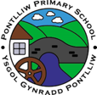  Chair of Governors: Mr I Humphreys  Review Date: July 2026
